**Tensors and Gradient Tape**

**Latest Submission Grade 100%**

**1.**

Question 1

A *Tensor* is a flexible data structure that can hold data in a variety of different ways.

**1 / 1 point**



True



False

**Correct**

Correct!

**2.**

Question 2

A Tensor can be a vector, matrix or multi-dimensional array but not a scalar

**1 / 1 point**



False



True

**Correct**

Correct! A tensor can be a scalar

**3.**

Question 3

You want to create a tensor object that is a 2 by 3 matrix containing all -1 values. You also want to be able to modify the values inside the tensor in the future. Which of the following lines of code should you use? Check all that are true.

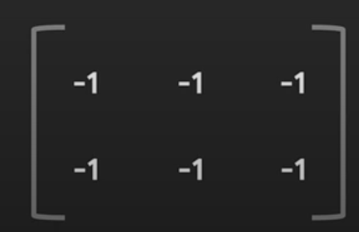

**1 / 1 point**



tf.constant([-1, -1, -1, -1, -1, -1], shape=[2, 3])



tf.Variable([[-1, -1, -1], [-1, -1, -1]], dtype=tf.int32)

**Correct**

Correct!



tf.Variable([[-1, -1, -1], [-1, -1, -1]], shape=[2, 3])

**Correct**

Correct! This code will run, but the shape will automatically be derived from the initial value (the list of lists). The dtype will be derived from the initial value, which is tf.int32.



tf.Variable([-1, -1, -1, -1, -1, -1], tf.int32, shape=[2,3])

**4.**

Question 4

One type of mode in TensorFlow allows for immediate evaluation of values. What is this mode called?

**1 / 1 point**



Graph mode



Eager mode

**Correct**

Correct! In general, this way of handling code (whether it’s in TensorFlow or any other programming language) is called “eager execution”.

**5.**

Question 5

Consider the following code:

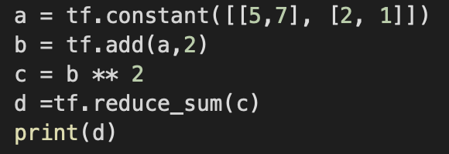

The output of the code *could* be: tf.Tensor(*x*, shape=(), dtype=int32)

What is the value of “x” in this case ? Enter in the box below. Enter “0” if you think the code above will run into some kind of error.

**1 / 1 point**

155

**Correct**

Correct!

**6.**

Question 6

What is the name of the TensorFlow API which handles automatic differentiation?

**1 / 1 point**



TapeGradient



Gradient



GradientTape



AutoDiff

**Correct**

Correct!